Commutative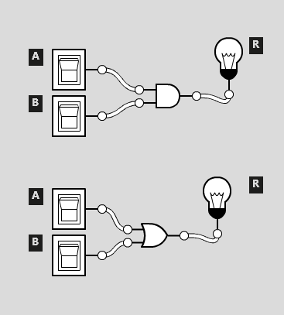 equivalence law

a ∧ b ≡ b ∧ a (Fig 1)

a ∨ b ≡ b ∨ a (Fig 2)

Associative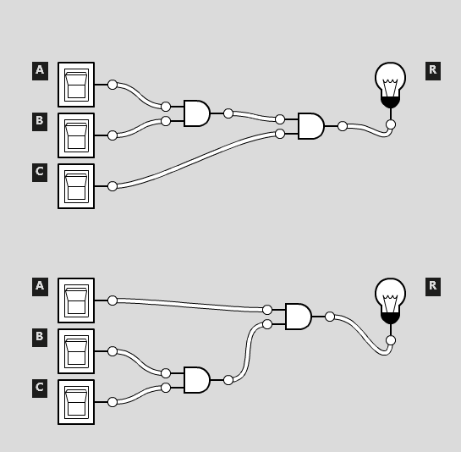 equivalence law

(a ∧ b) ∧ c ≡ a ∧ (b ∧ c)

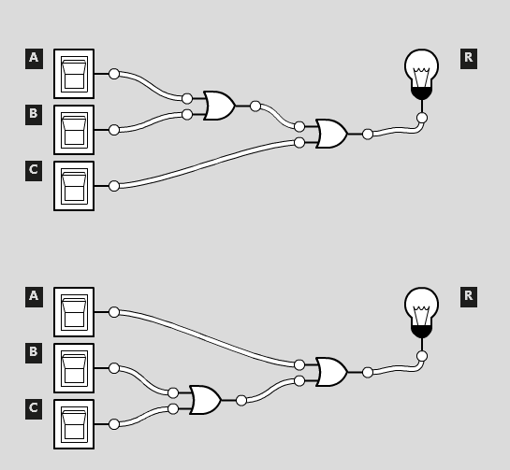

Associative equivalence law

(a ∨ b) ∨ c ≡ a ∨ (b ∨ c)

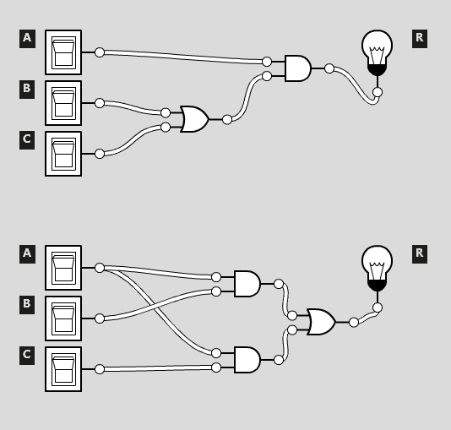

Distributive equivalence law

a ∧ (b ∨ c) ≡ (a ∧ b) ∨ (a ∧ c)

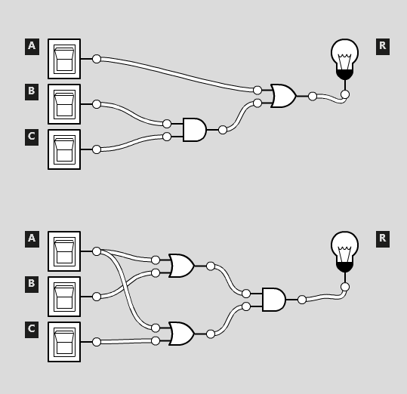

Distributive equivalence law

a ∨ (b ∧ c) ≡ (a ∨ b) ∧ (a ∨ c)

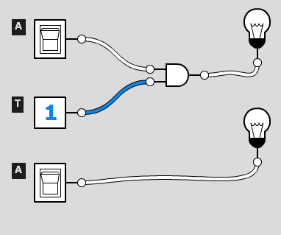

Identity equivalence law

a ∧ t ≡ a

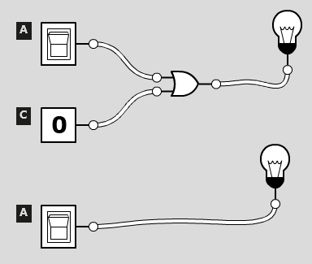

Identity equivalence law

a ∨ c ≡ a

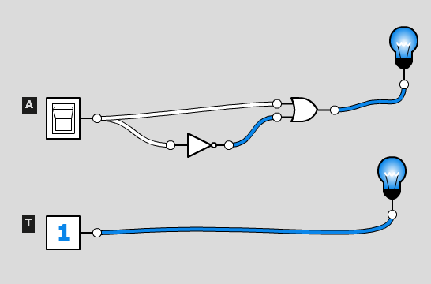

Negation equivalence law

a ∨ ¬a ≡ t

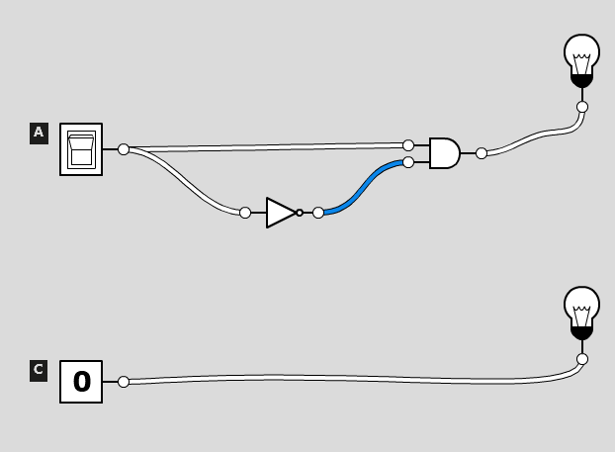

Negation equivalence law

a ∧ ¬a ≡ c

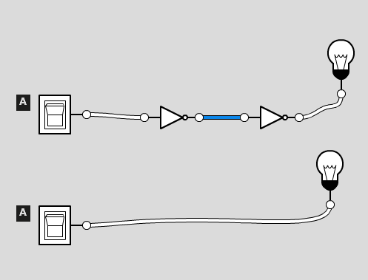

Negation equivalence law

¬(¬a) ≡ a

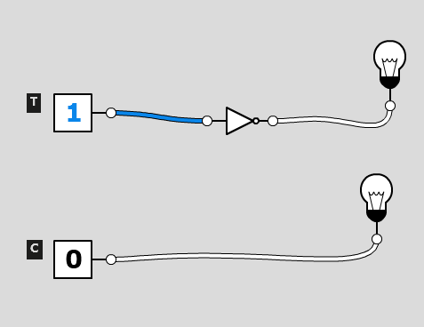

Negation equivalence law

¬ t ≡ c

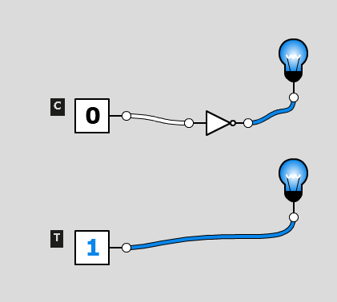

Negation equivalence law

¬ c ≡ t

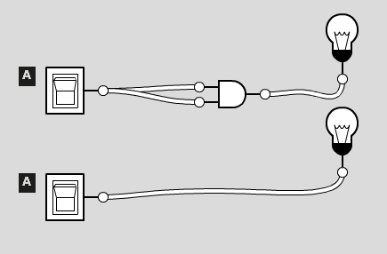

Idempotent equivalence law

a ∧ a ≡ a

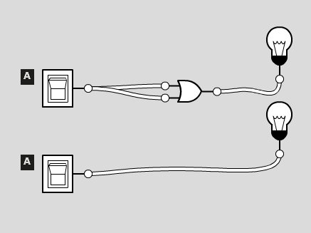

Idempotent equivalence law

a ∨ a ≡ a

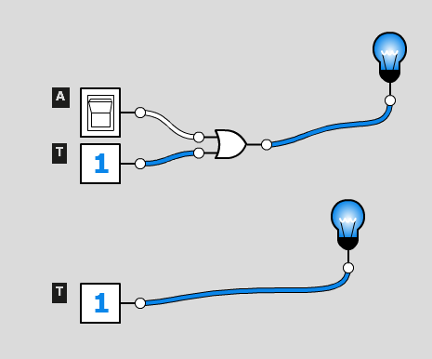

Universal bounds equivalence law

a ∨ t ≡ t

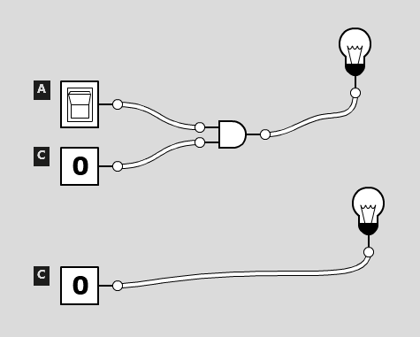

Universal bounds equivalence law

a ∧ c ≡ c

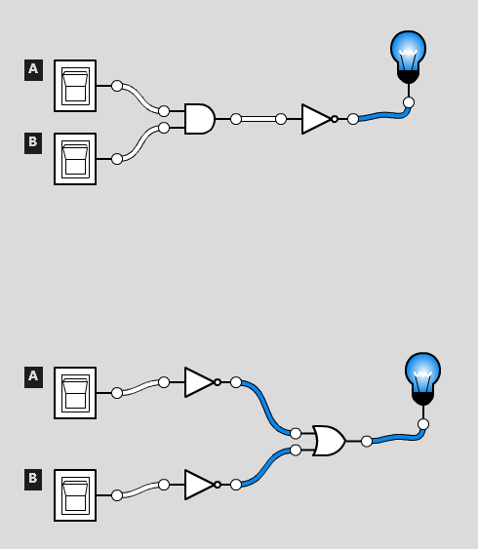

De Morgan’s equivalence law

¬(a ∧ b) ≡ ¬a ∨ ¬b

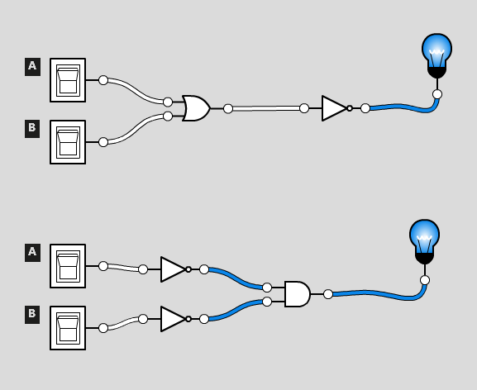

De Morgan’s equivalence law

¬(a ∨ b) ≡ ¬a ∧ ¬b

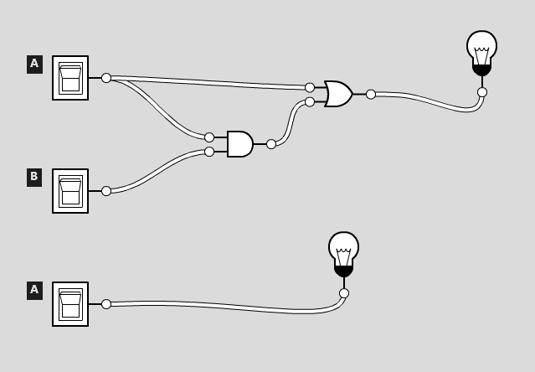

Absorption equivalence law

a ∨ (a ∧ b) ≡ a

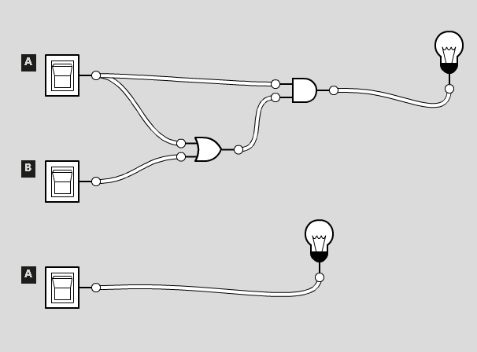

Absorption equivalence law

a ∧ (a ∨ b) ≡ a